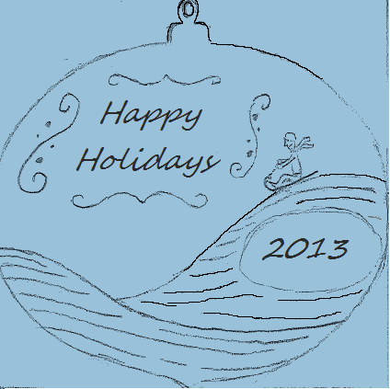
3 Selections
- Happy Holidays
- Merry Christmas
- Custom (7 Characters Maximum Top Row, 8 Characters Maximum Bottom Row)
2 Options
- 2013
- School Logo

